- Complete the DNA. SET A
Sense | T | G | A | T | G | C | C | C | T | T | T | C | A | C | T | G | T | C | G | G | G | T | A | G | T | C | C | C | T | G | A | T | T | A | C | A | G | G | T | G | A | T
Antisense
(COMPLEMENTARY)

-------------------cut----------------------------------------------------------------------------------------------------------------------------------------------------------------------------------------------------------------------------------------------------------------------------------------------
- Transcription (you are RNA polymerase) SET A
mRNA

Send to the ribosome, through the nuclear membrane.
-------------------cut-----------------------------------------------------------------------------------------------------------------------------------------------------------------------------------------------------------------------------------------------------------------------------------------------
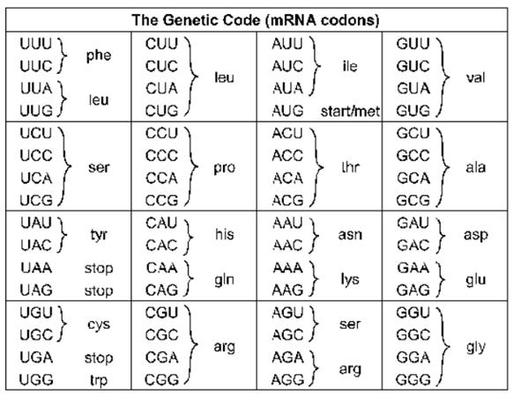
- Identify the codons and write the amino acid sequence. You are the ribosome. SET A

Sequence:

How many codons?

How many amino acids?

How many base pairs?

- Complete the DNA. SET B
Sense | A | T | T | A | T | G | T | T | C | C | G | A | G | A | T | T | A | C | C | A | G | A | T | T | A | C | C | A | C | G | G | A | G | T | C | A | C | C | G | T | A | A
Antisense
(COMPLEMENTARY)

-------------------cut----------------------------------------------------------------------------------------------------------------------------------------------------------------------------------------------------------------------------------------------------------------------------------------------
- Transcription (you are RNA polymerase) SET B
mRNA

Send to the ribosome, through the nuclear membrane.
---------------------- cut ----------------------------------------------------------------------------------------------------------------------------------------------------------------------------------------------------------------------------------------------------------------------------------------
- Identify the codons and write the amino acid sequence. You are the ribosome. SET B

Sequence:

How many codons?

How many amino acids?

How many base pairs?

