Title (similar to aim)
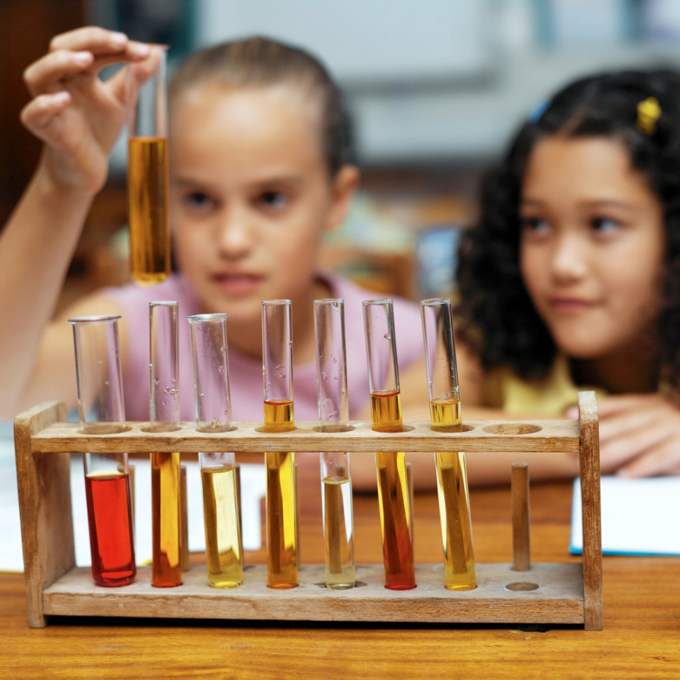
Cite the picture if it is not your own.

Name
Class
Bandung International School
Date lab was performed

DESIGN
BACKGROUND INFORMATION: This section should be at least a couple of paragraphs to introduce key concepts about your lab. In this case discuss what you know about pH.
AIM: A singular statement or question. What is the point of this lab?
HYPOTHESIS: Single statement of what you believe to be true. Do not write in the first person. Look at the chemical formula to guess what will happen.
EXPLANATION OF HYPOTHESIS: This explanation should support your hypothesis scientifically. Why do you think this will happen?
MATERIALS: see page 27 but use your own words.
METHODS: see page 27 but use your own words.

DISCUSSION QUESTIONS:
- What type of reaction is this?
- How do you know?
- What are some other characteristics of this type of reaction?
- Why do people often burp after eating sherbet?
- Which materials were acidic?
- Which materials were basic?
- How do you know?
- List the reactants.
- List the products.
- How would you improve this lab?

