Blog resource: <http://tinyurl.com/3327h6r>

Cite all sources using the CSE method (or ISO 690 Numerical in Word). The first example has been done for you.

Complete the self-assessment rubric before submitting to Moodle. Avoid printing this if possible.

1. **Species’ reproductive cycles are the product of natural selection**
2. Distinguish between *r- and K- reproductive strategies*:

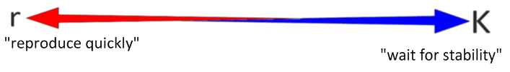

|  |  |  |
| --- | --- | --- |
| Short life span (days, weeks or months) (1) | **Life span** |  |
|  | **Growth** |  |
|  | **Maturity** |  |
|  | **Offspring** |  |
|  | **Competition** |  |
|  | **examples** |  |

1. State some species that could be considered exceptions to this theory.
2. Discuss the environmental conditions which favour either r- or K-strategies.
3. Using r-K strategist theory, describe how disasters can lead to outbreaks of disease.
4. **Populations of animal species can be monitored using capture-mark-recapture methods.**
5. Annotate the Lincoln Index calculation below, as an example of a capture-mark-recapture method of estimating the population size of an animal species.

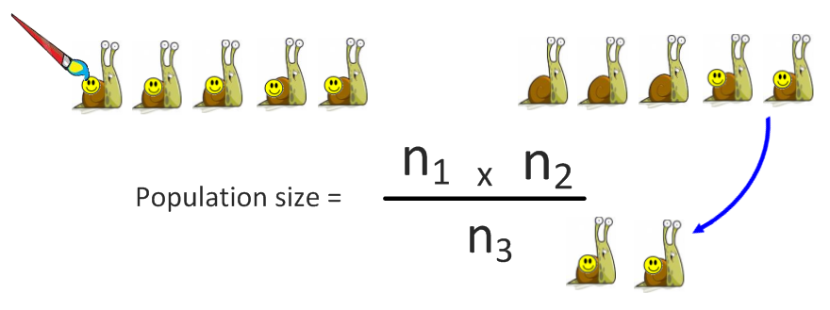

1. Calculate the population of cartoon snails in the illustration above. Show your working.

P=______

1. Outline some of the ethical and practical considerations of capture-mark-recapture methods.

|  |  |  |
| --- | --- | --- |
|  | **Practical considerations** | **Ethical considerations** |
| Capturing |  |  |
| Marking |  | Marking must not be harmful to the animals, affect their natural markings or communications or make them more noticeable to predators or prey. |
| Animal behaviour |  |  |
| Sample sizes | Efficient sample methods and sufficient time allow for more reliable data to be collected | Capturing and marking large parts of a population may lead to unforeseen negative consequences. |

1. Use the Lincoln Index to monitor this mountain gorilla population over time:

|  |  |  |  |  |  |  |
| --- | --- | --- | --- | --- | --- | --- |
| Year | **2003** | **2004** | **2005** | **2006** | **2007** | **2008** |
| n1 | 23 | 26 | 27 | 16 | 18 | 17 |
| n2 | 25 | 30 | 35 | 18 | 19 | 24 |
| n3 | 18 | 22 | 21 | 15 | 16 | 17 |
| **P** |  |  |  |  |  |  |

1. Gorilla hunting is illegal in some regions and carefully controlled in others, though there is a high demand for illegal *bush-meat*.
2. Deduce between which two years illegal hunters were active in the forest.
3. Explain the long recovery time for the population.
4. Describe how the following conservation method could be used to preserve the mountain gorilla populations (link with G4 Conservation of Biodiversity).

Nature reserves

In-situ active management

Education

Economic stimulus

1. The state of the oceans is one of the most pressing and dangerous threats to humanity.

Watch the video: *“*[*Five things you need to know about the oceans*](http://www.youtube.com/watch?v=s3u2ZxKhPoA)*”* from [oceana.org](http://eu.oceana.org/en).

1. Summarise the main points below:

Read the article “[*Next Year’s TAC’s: How scientists estimate and forecast fish stocks*](https://www.box.net/shared/65eoo4hhhx)” (original article can be found in the CEFAS database: <http://www.cefas.co.uk/publications.aspx>)

1. Describe the following catch-based methods of estimating fish stock population size:

Catch volume

Catch rate

Catch by age (how is this measured?)

1. Outline the limitations of using the Lincoln Index for fish stocks.
2. List some of the technological methods used to estimate fish stock size.
3. Explain the concept of *maximum sustainable yield*. Use a sketch graph.
4. Fish stocks can be considered a renewable resource.
5. Explain why we can consider this.
6. What are the limitations to using fisheries as a renewable resource?
7. Deciding on the next year’s total allowable catch is a difficult and political pursuit.

* List the main stakeholders and their interests in fish stocks.
* List the data collected to set TAC’s

1. The Food and Agricultural Organization (FAO) gathered information to determine if marine ecosystems were being damaged by overfishing. The total fish captured in each of three oceans from the years 1960 to 2000 was compared to the overall world marine capture.



From IB QuestionBank [Source: R Buckley (editor), *World Fishing: Beyond Sustainability,* (2002),  
Understanding Global Issues Limited, pages 8–9]

(a) Calculate the percentage of the world catch that came from the Atlantic Ocean in 1990.

**(1)**

(b) Compare the data from the Pacific Ocean with that from the Atlantic Ocean.

**(3)**

(c) Suggest **one** reason in each case for the change in the quantity of fish captured in the Atlantic and Indian Oceans from 1980 to 1990.

Atlantic Ocean:

Indian Ocean:

**(2)**

**(Total 6 marks)**

1. Outline the ecological and socio-economic impacts of a fishery collapse.
2. Discuss the **international measures** that can promote the conservation of fish stocks.

* <http://marinebio.org/Oceans/Conservation/sustainable-fisheries.asp>
* <http://ec.europa.eu/fisheries/cfp_en.htm>

|  |  |  |
| --- | --- | --- |
| **Quotas (TACs) and monitoring** | **Moratoria on endangered species** | **Closed seasons** |
|  |  |  |
| **Exclusion zones** | **Minimum net hole sizes** | **Banning of drift nets** |
|  |  |  |

**Big challenges:**

# Works Cited

1. **Taylor, Stephen.** G5 Population Ecology (presentation). *Science Video Resources.* [Online] September 2010. http://sciencevideos.wordpress.com/options/05-ecology-evolution-and-conservation/g5-hl-population-ecology/.

2. **Allott, Andrew.** *IB Study Guide: Biology for the IB Diploma.* s.l. : Oxford University Press, 2007. 978-0-19-915143-1.

**Self Assessment:**

|  |  |  |  |  |  |
| --- | --- | --- | --- | --- | --- |
|  | **Essential Biology** | | | **Assessment** | |
| **Criterion** | **Complete (2)** | **Partially complete (1)** | | **Self** | **MrT** |
| Presentation & Organisation | NA | Complete and neat. All command terms highlighted, tables and diagrams well presented. | |  |  |
| Academic Honesty | NA | Sources cited using the CSE (ISO 690 numerical) method, with Works Cited section complete and correct. | |  |  |
| **Objective 1** understanding | **All** answers for the following command terms correct: | Most answers for the following command terms correct: | |  |  |
| **Define Draw Label List Measure State** | | |
| **Objective 2** understanding | **All** answers for the following command terms correct: | | Most answers for the following command terms correct: |  |  |
| **Annotate Apply Calculate Describe Distinguish Estimate Identify Outline** | | |
| **Objective3**  understanding | **All** answers for the following command terms correct: | | Most answers for the following command terms correct: |  |  |
| **Analyse Comment Compare Construct Deduce Derive Design Determine Discuss**  **Evaluate Explain Predict Show Solve Sketch Suggest** | | |
| Logic, notation, mathematical working | NA | Answers are presented in a logical and concise manner. SI units used most times, with correct unit symbols and definitions of terms. All mathematical working shown. | |  |  |
| Further research | NA | *Evidence* is apparent of research and reading beyond the textbook and presentations to find correct answers to challenging questions. **If any questions are unanswered, this criterion scores zero.** | |  |  |
|  | **Total (max 10):** | | |  |  |