Blog resource: http://tinyurl.com/249fd5a
Cite all sources using the CSE method (or ISO 690 Numerical in Word). The first example has been done for you.
Complete the self-assessment rubric before submitting to Moodle. Avoid printing this if possible.
- Define the following terms:

Species: A group of organisms that can interbreed to produce fertile offspring. ⁽¹⁾

Habitat

Population

Community

Ecosystem

Ecology

Niche

Biodiversity

Trophic level

- Complete the tree below with definitions and examples of each type of feeding strategy.
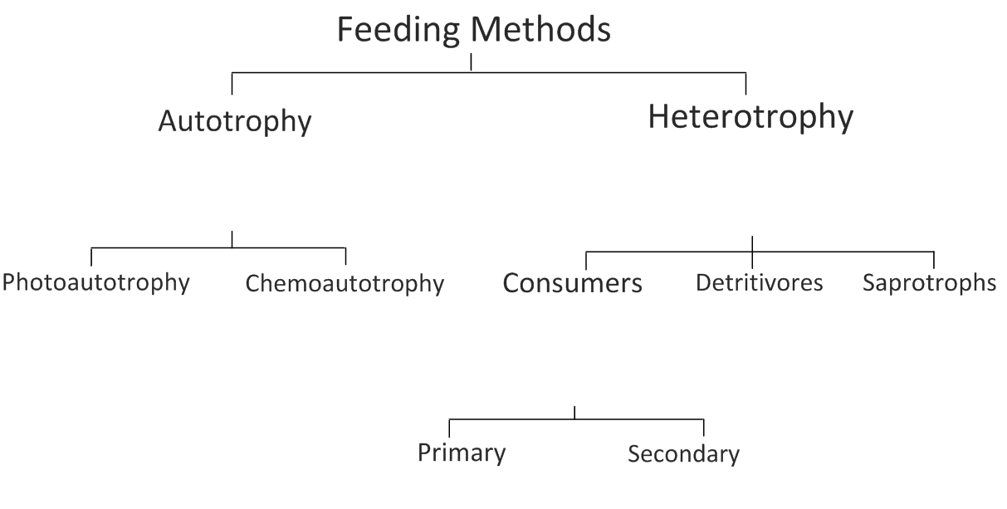
Distinguish between the feeding strategies at each level of the diagram.
- Food chains represent the flow of energy and nutrients in a series of feeding relationships.
Give one example of a marine food chain (min. 4 organisms)

Give one example of a terrestrial food chain (min. 4 organisms)

Give one other example of a food chain (min. 4 organisms)

- Describe what is meant by a food web.

- The food web below shows some coral reef feeding relationships;
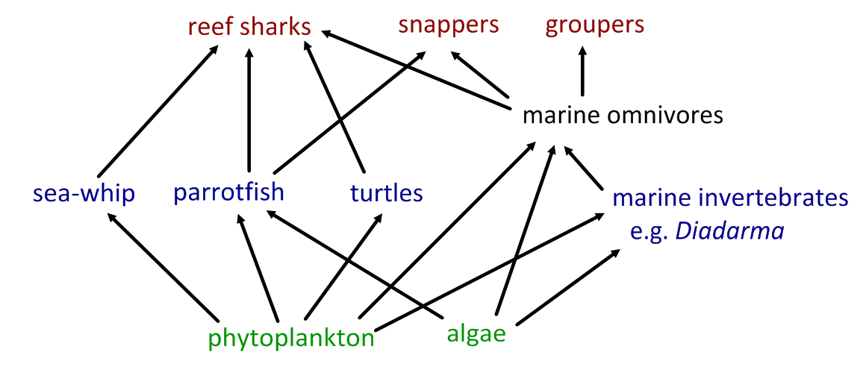
- Identify species in the following trophic levels:
- Producers

- Primary consumers

- Secondary consumers

- On a separate sheet, construct a freshwater food web based on the following information:
Organism | Energy sources
Water crowfoot | Sunlight
Cased caddisfly larva | Micro-plants, algae, particles of dead plants and animals
Damselfly nymph | Micro-plants, algae, particles of dead plants and animals
Mayfly nymph | Micro-plants, algae, particles of dead plants and animals
Dragonfly | Other adult insects and small flies
Duck | All nymphs, all plants, snails, tadpoles, young frogs
Freshwater Shrimp | Particles of dead plants and animals
Water vole | Plants
Algae | Sunlight
Otter | Fish, frogs and newts
Water starwort | Sunlight
Pond snail | Microplants, all water plants and algae
Alderfly nymph | Micro-plants, algae, particles of dead plants and animals
Pond skater | Particles of dead plants and animals
Frog | Mayfly, midge larvae, pond skater, caddisfly, small flies
Tadpole | Micro-plants, algae
Micro-plants | Sunlight
Great diving beetle | Water flea, snails, tadpole, all nymphs
Bullhead fish | Diving beetle, tadpole, all nymphs, water flea, snail, midge larvae
Adapted from: http://www.cornwallriversproject.org.uk/education/education_pack.htm

- For the food web created above:
- Identify organisms in each of the trophic levels.

- Identify organisms that fit more than one trophic level.

- Identify those which could be classed as detritivores

- Suggest why it is sometimes difficult to classify organisms into trophic levels.

- Outline why numbers of organisms are smaller at higher trophic levels.

- State the original source of energy for almost all communities.

- Explain how energy flows through a community, including why energy transfers are never 100% efficient.

- State the function of a pyramid of energy.

- Give an example of a unit of measurement used in a pyramid of energy, giving a description of each component.

- “Energy flows through an ecosystem, nutrients are recycled.”
Explain this statement with the aid of a flow chart. Include the roles of saprotrophic bacteria and fungi.

- Outline three examples of cycles of inorganic nutrients. For each, outline the uses of the nutrients in living organisms, its method of transfer into and through the food chain and how it is returned to the inorganic nutrient pool.
  - Carbon
  - Nitrogen
  - Calcium

Works Cited
1. Taylor, Stephen. Communities and Ecosystems. Science Video Resources (presentation). [Online] October 2009. http://sciencevideos.wordpress.com/bis-ib-diploma-programme-biology/05-ecology-and-evolution/02-communities-ecosystems
2. Allott, Andrew. IB Study Guide: Biology for the IB Diploma. s.l. : Oxford University Press, 2007. 978-0-19-915143-1.

Self Assessment:
 | Essential Biology |  |  | Assessment
Criterion | Complete (2) | Partially complete (1) |  | Self | MrT
Presentation & Organisation | NA | File names sensible, work complete and well-presented. Filed in order of topic, and easy to access. All command terms highlighted or underlined.
Academic Honesty | NA | Sources cited using the CSE (ISO 690 numerical) method, with Works Cited section complete and correct.
Objective 1 understanding | All answers for the following command terms correct: | Most answers for the following command terms correct:
 | Define Draw Label List Measure State
Objective 2 understanding | All answers for the following command terms correct: |  | Most answers for the following command terms correct:
 | Annotate Apply Calculate Describe Distinguish Estimate Identify Outline
Objective3  understanding | All answers for the following command terms correct: |  | Most answers for the following command terms correct:
Analyse Comment Compare Construct Deduce Derive Design Determine Discuss
Evaluate Explain Predict Show Solve Sketch Suggest
Logic, notation, mathematical working | NA | Answers are presented in a logical and concise manner. SI units used most times, with correct unit symbols and definitions of terms. All mathematical working shown.
Further research | NA | Evidence is apparent of research and reading beyond the textbook and presentations to find correct answers to challenging questions. If any questions are unanswered, this criterion scores zero.
 | Total (max 10):

