Resources: http://sciencevideos.wordpress.com/ahl/08-cell-respiration-photosynthesis/8-2-photosynthesis/
Complete the questions, citing your answers using the CSE method (or ISO 690 numerical on Word). The first one has been done for you, as an example. Don’t forget to superscript the in-text citation.
- Summarise photosynthesis in an annotated symbol equation:
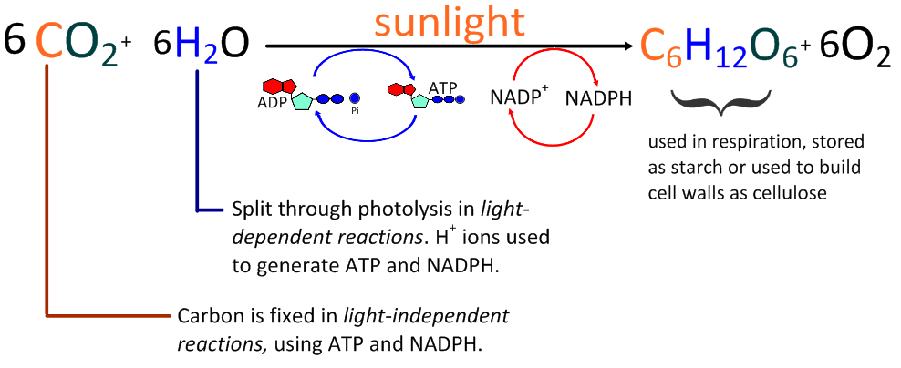 ⁽¹⁾

- Summarise the two main stages of photosynthesis:
 | Input | Outcome
Light-dependent
Light independent

- Draw and annotate the structure of a chloroplast, as seen through a transmission electron microscope, including a scale bar. Include functions of each component.

- Light Dependent Reactions
- Annotate the diagram below to explain the light-dependent reactions of photosynthesis, including photolysis, photoactivation of electrons, electron transfer, chemiosmosis, non-cyclic phosphorylation and the use of NADP⁺.

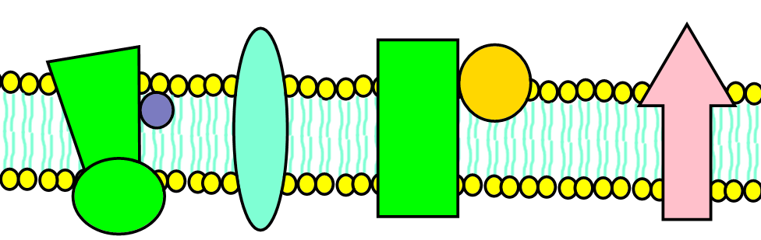

- Compare the light dependent reactions of photosynthesis with the electron transport chain and photophosporylation of cell respiration.

- Use the axes below to explain the relationship between the action spectrum of photosynthesis and absorption spectrum of chlorophyll, including the significance of the two peaks at the red end of the action spectrum.
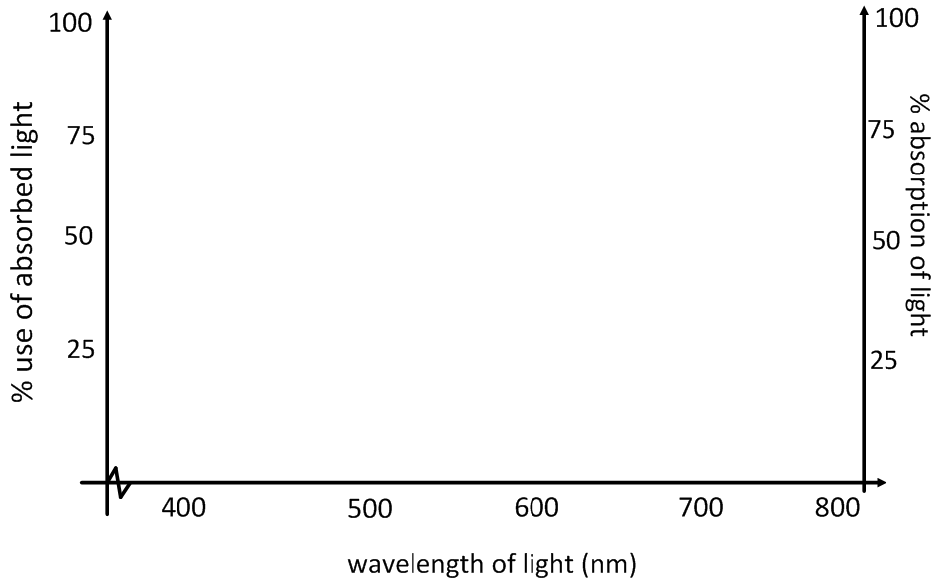

- Describe two uses of light in photosynthesis.

- Light-independent reactions
- State the names and roles of two products of the light-dependent reactions in the light-independent reactions.

- State the name of compounds in the Calvin cycle containing the following numbers of carbon atoms:
Six:
Five:
Three:
One:

- Define carbon fixing, carboxylation and decarboxylation.

- In the space below, draw a diagram to explain the Calvin cycle (light-independent reactions). Include carboxylation of RuBP to glycerate-3-phosphate by rubisco, reduction to triose phosphate, formation of glucose phosphate and reformation of RuBP.

- Structure and Function
- Explain how the structure of a chloroplast shows adaptations to its functions.

- Compare chloroplasts and mitochondria in terms of structure, function and adaptations.

- A limiting factor is the one factor which is in shortest supply or is preventing the rate of a reaction from increasing. If this factor were increased, rate of reaction would increase until another plateau was reached (a different factor is then limiting).

- Using the graph below, deduce, with reasons, the most important limiting factor in the rate of photosynthesis of this green plant.
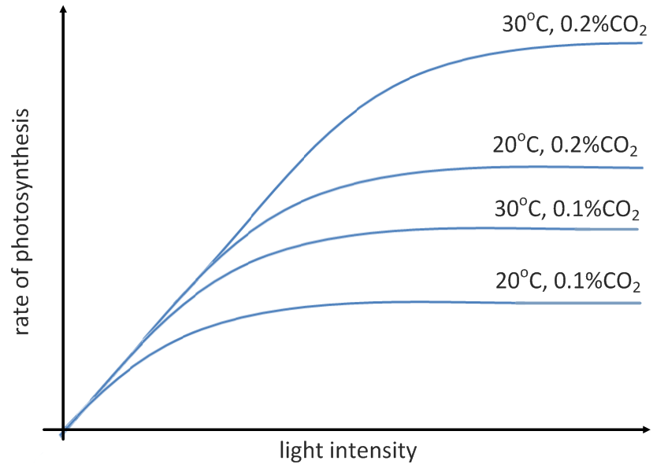

- Explain how the following factors can limit the rate of photosynthesis of green plants:
(give reasons specific to the reactions of photosynthesis)

CO₂ concentration  Commonly limiting factor | Function | Carbon fixation in light-dependent reactions. Used to carboxylate RuBP, forming 2x glycerate-3-phosphate (GP) molecules.
 | Direct effects if limited | Glucose-phosphate production reduces, reduced output of starch or cellulore. RuBP builds up, GP not converted to triose phosphate so ATP and NADPH are not used and are not recycled back to light dependent reactions.
Light intensity  Not commonly limiting factor | Function
 | Direct effects if limited
Temperature  Commonly limiting factor at the low end | Function
 | Direct effects if limited

- Deduce the effects of soil low in phosphate-based nutrients on primary productivity of green plants, explaining your answer with knowledge of the processes of photosynthesis.

- Discuss how manipulation of the limiting factors in the controlled environment of a commercial greenhouse might boost productivity.

Works Cited
1. Taylor, Stephen. Photosynthesis (C4 & AHL). SlideShare. [Online] 06 23, 2010. http://www.slideshare.net/gurustip/photosynthesis-c4-ahl.

