Blog resource: http://tinyurl.com/5vfw6ye Click4Biology: http://click4biology.info/c4b/4/gene4.htm
Cite all sources using the CSE method (or ISO 690 Numerical in Word. Highlight all objective 1 command terms in yellow and complete these before class. Highlight all objective 2 and 3 command terms in green – these will be part of the discussions in class. After class, go back and review them.
Complete the self-assessment rubric before submitting to Moodle. Avoid printing this if possible.
- Define homologous chromosomes.

- Explain reduction division.

- State the function of meiosis.

- Add chromosomes and annotate the diagram below summarizing the steps in meiosis.
Identify the stage where crossing over occurs and state its effect.

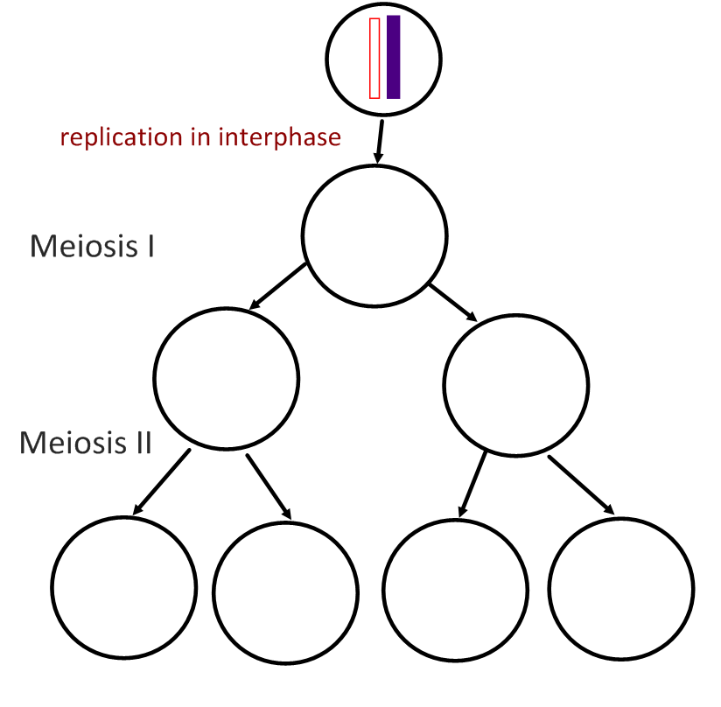

- Compare mitosis and meiosis:
 | Mitosis | Meiosis
Number of divisions
Number of daughter cells
Chromosome number in daughter cells
Functions:

- Outline the major events and movements of chromosomes occurring at these stages of meiosis:
Meiosis I |  |  | Meiosis II
Interphase |  |  | Interphase | No replication occurs in interphase between Meiosis I and II.
Prophase I |  |  | Prophase II
Metaphase I |  |  | Metaphase II
Anaphase I |  |  | Anaphase II
Telophase I |  |  | Telophase II
Cytokinesis |  |  | Cytokinesis

- Deduce the answers to these questions.
a. A cell with a diploid number of 12 chromosomes meiosis. How many daughter cells will be produced and with how many chromosomes in each?
- Cells:
- Chromosomes:
b. A gamete contains 18 chromosomes. How many chromosomes in the somatic cell?
- Chromosomes:

c. A diploid cell with 16 chromosomes undergoes meiosis. How many chromatids are present in metaphase I?
- Chromatids:

- A cell with a chromosome number (n) of 3 undergoes meiosis. Draw a series of diagrams to outline the steps of meiosis.
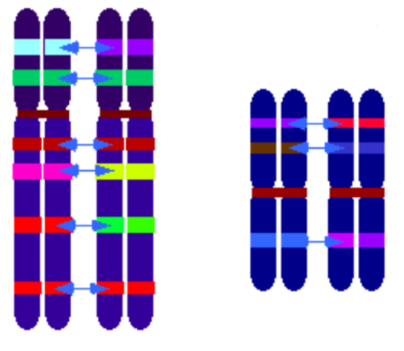
- Describe what you can see in this image.

- Distinguish between chromosomes, sister chromatids and bivalents.

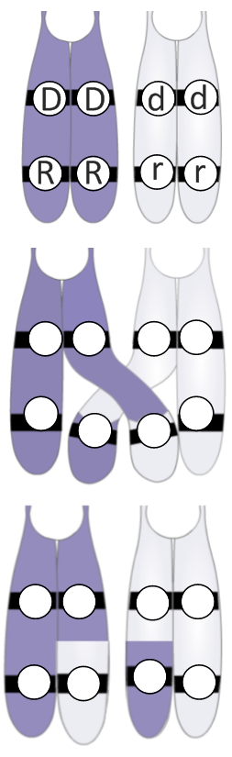
- State during which stage of meiosis is the image in Q8 most likely to be seen.

- Outline the process of crossing over and annotate the diagram.

Synapsis

Chiasma formation

Separation

- State the effect of crossing over in terms of genetic diversity.

- A diploid cell carries genes A and B. There are dominant and recessive alleles for these genes. The cell is heterozygous for both genes.
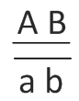
- What combination of gametes could be produced if there was no crossing over?
- AB or ____

- What combinations of gametes could be produced if a chiasma formed between the loci of genes A and B?

- The rough image shows chromosomes forming chiasmata.
How many of the following structures are present?

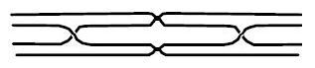
Chromosomes:

Centromeres:

Sister Chromatids:

Chiasmata:

- Outline how random orientation in metaphase I leads to further genetic variation.
State the number of orientations possible in human cells.

- Mendel made many advances in genetics through careful observation and statistical analysis.
  - State Mendel’s Law of Independent Assortment

  - What assumption is made here?
  - There is no ______________

  - Explain the link between the law of independent assortment and meiosis.

- Outline how sexual reproduction leads to even further genetic variation within a species.

- Annotate the diagram below to show what happens in non-disjunction in meiosis II.
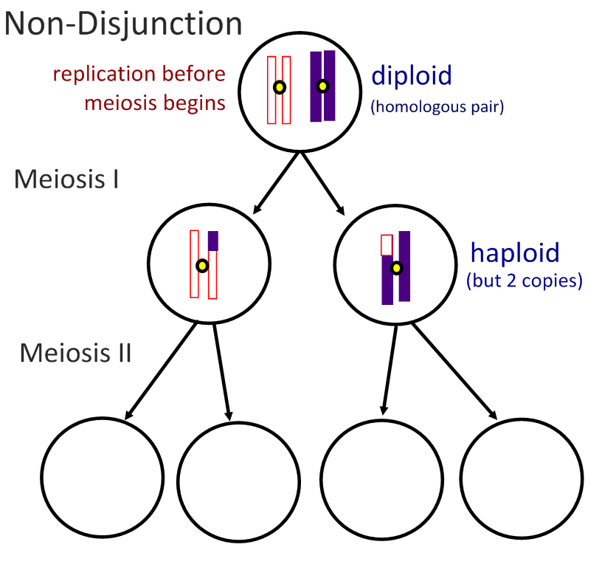

- Describe how non-disjunction and fertilisation lead to trisomy.
- Non-disjunction:
- Fertilisation:

- Distinguish between non-disjunction and trisomy.
- Non-disjunction:
- Trisomy:

- Compare the outcomes of non-disjunction in anaphase I with anaphase II:

Non-disjunction in… | Anaphase I | Anaphase II
Number of normal cells
Cells with extra chromosome (n+1)
Cells with chromosome missing (n-1)

- Using information in the graph, outline the effect of maternal age on likelihood of Down Syndrome:
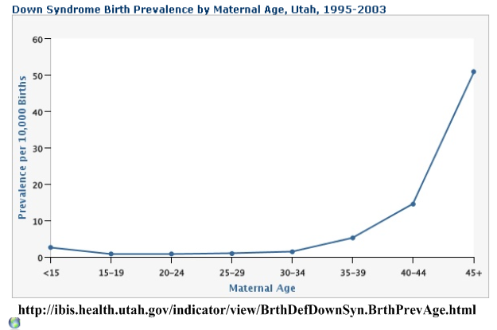

- Describe the effects of Down syndrome.

- Compare the outcomes of non-disjunction in anaphase I with anaphase II:

Non-disjunction in… | Anaphase I | Anaphase II
Number of normal cells
Cells with extra chromosome (n+1)
Cells with chromosome missing (n-1)

- A karyotype can be used to test for non-disjunction disorders. Fetal cells are taken and the number of chromosomes counted. Outline how these cells are retrieved:
Chorionic Villus Sampling (CVS):

Amniocentesis:

- Describe how performing a nuchal translucency (NT) scan can reduce the number of healthy fetuses terminated as a result of amniocentesis. http://www.guardian.co.uk/society/2009/may/16/health-nhs

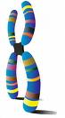

- State three visual aspects of homologous chromosomes which can be used to identify them for the purpose of a karyotype?
- Banding patterns

- Analyse this karyotype:
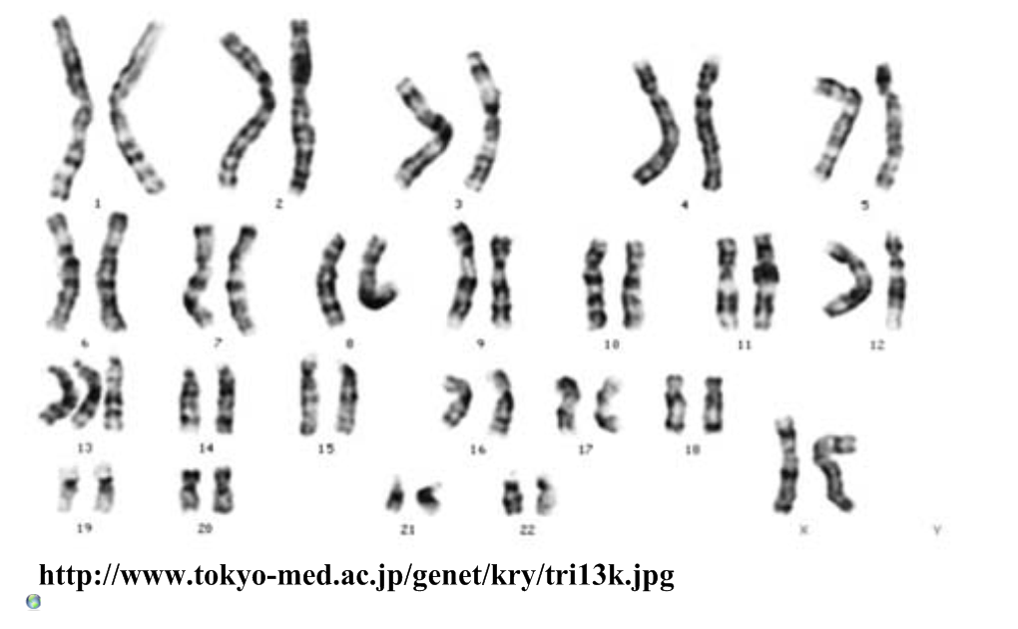
Gender: Condition:

Remember: Meiosis is the key to success in Biology. If we understand how meiosis works and gives rise to genetic variation, we can understand how life has evolved and adapted. Make sure you can explain all of the ways in which meiosis leads to variation amongst a population.

Works Cited
1. Allott, Andrew. IB Study Guide: Biology for the IB Diploma. s.l. : Oxford University Press, 2007. 978-0-19-915143-1.
2. Mindorff, D and Allott, A. Biology Course Companion. Oxford : Oxford University Press, 2007. 978-099151240.
3. Clegg, CJ. Biology for the IB Diploma. London : Hodder Murray, 2007. 978-0340926529.
4. Campbell N., Reece J., Taylor M., Simon. E. Biology Concepts and Connections. San Fransisco : Pearson Benjamin Cummings, 2006. 0-8053-7160-5.
5. Taylor, Stephen. Science Video Resources. [Online] Wordpress, 2010. http://sciencevideos.wordpress.com.
6. Burrell, John. Click4Biology. [Online] 2010. http://click4biology.info/.
7. IBO. Biology Subject Guide. [Online] 2007. http://xmltwo.ibo.org/publications/migrated/production-app2.ibo.org/publication/7/part/2/chapter/1.html.

Self Assessment:
 | Essential Biology |  |  | Assessment
Criterion | Complete (2) | Partially complete (1) |  | Self | MrT
Presentation & Organisation | NA | Complete and neat. All command terms highlighted, tables and diagrams well presented.
Academic Honesty | NA | Sources cited using the CSE (ISO 690 numerical) method, with Works Cited section complete and correct.
Objective 1 understanding | All answers for the following command terms correct: | Most answers for the following command terms correct:
 | Define Draw Label List Measure State
Objective 2 understanding | All answers for the following command terms correct: |  | Most answers for the following command terms correct:
 | Annotate Apply Calculate Describe Distinguish Estimate Identify Outline
Objective3  understanding | All answers for the following command terms correct: |  | Most answers for the following command terms correct:
Analyse Comment Compare Construct Deduce Derive Design Determine Discuss
Evaluate Explain Predict Show Solve Sketch Suggest
Logic, notation, mathematical working | NA | Answers are presented in a logical and concise manner. SI units used most times, with correct unit symbols and definitions of terms. All mathematical working shown.
Further research | NA | Evidence is apparent of research and reading beyond the textbook and presentations to find correct answers to challenging questions. If any questions are unanswered, this criterion scores zero.
 | Total (max 10):

