Blog resource: http://tinyurl.com/69yqaxk Click4Biology: http://tinyurl.com/68c8g3j
Cite all sources using the CSE method (or ISO 690 Numerical in Word. Highlight all objective 1 command terms in yellow and complete these before class. Highlight all objective 2 and 3 command terms in green – these will be part of the discussions in class. After class, go back and review them.
Complete the self-assessment rubric before submitting to Moodle. Avoid printing this if possible.
- Identify the phase of the cell cycle during which DNA replication occurs.

- State the function of DNA replication.

- Identify the end product of DNA replication in a human somatic cell.
- 23 chromosomes
- 46 chromosomes
- 23 pairs of chromosomes
- 23 pairs of sister chromatids

- Describe how mitosis ensures that each new daughter cell is identical (mitosis review).

- Explain the process of DNA Replication:

- DNA Helicase unwinds and unzips the DNA double helix:

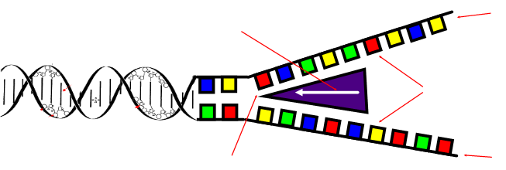

- DNA polymerase creates complementary strands:

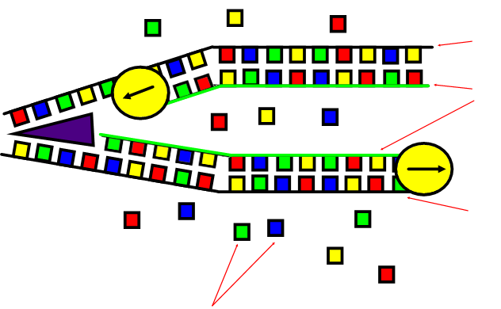

- Explain the importance of complementary base pairing in conserving the base-sequence during DNA Replication.

- Describe why DNA replication is considered ‘semi-conservative’.

Works Cited
1. Allott, Andrew. IB Study Guide: Biology for the IB Diploma. s.l. : Oxford University Press, 2007. 978-0-19-915143-1.
2. Mindorff, D and Allott, A. Biology Course Companion. Oxford : Oxford University Press, 2007. 978-099151240.
3. Clegg, CJ. Biology for the IB Diploma. London : Hodder Murray, 2007. 978-0340926529.
4. Campbell N., Reece J., Taylor M., Simon. E. Biology Concepts and Connections. San Fransisco : Pearson Benjamin Cummings, 2006. 0-8053-7160-5.
5. Taylor, Stephen. Science Video Resources. [Online] Wordpress, 2010. http://sciencevideos.wordpress.com.
6. Burrell, John. Click4Biology. [Online] 2010. http://click4biology.info/.
7. IBO. Biology Subject Guide. [Online] 2007. http://xmltwo.ibo.org/publications/migrated/production-app2.ibo.org/publication/7/part/2/chapter/1.html.

Self Assessment:
 | Essential Biology |  |  | Assessment
Criterion | Complete (2) | Partially complete (1) |  | Self | MrT
Presentation & Organisation | NA | Complete and neat. All command terms highlighted, tables and diagrams well presented.
Academic Honesty | NA | Sources cited using the CSE (ISO 690 numerical) method, with Works Cited section complete and correct.
Objective 1 understanding | All answers for the following command terms correct: | Most answers for the following command terms correct:
 | Define Draw Label List Measure State
Objective 2 understanding | All answers for the following command terms correct: |  | Most answers for the following command terms correct:
 | Annotate Apply Calculate Describe Distinguish Estimate Identify Outline
Objective3  understanding | All answers for the following command terms correct: |  | Most answers for the following command terms correct:
Analyse Comment Compare Construct Deduce Derive Design Determine Discuss
Evaluate Explain Predict Show Solve Sketch Suggest
Logic, notation, mathematical working | NA | Answers are presented in a logical and concise manner. SI units used most times, with correct unit symbols and definitions of terms. All mathematical working shown.
Further research | NA | Evidence is apparent of research and reading beyond the textbook and presentations to find correct answers to challenging questions. If any questions are unanswered, this criterion scores zero.
 | Total (max 10):

