Blog resource: http://tinyurl.com/69yqaxk Click4Biology: http://tinyurl.com/46env5l
Cite all sources using the CSE method (or ISO 690 Numerical in Word). Highlight all objective 1 command terms in yellow and complete these before class. Highlight all objective 2 and 3 command terms in green – these will be part of the discussions in class. After class, go back and review them.
Complete the self-assessment rubric before submitting to Moodle. Avoid printing this if possible.
- Label the structures of this single nucleotide.
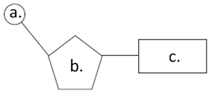 | a.
 | b.
 | c.

- Complete the table below to show the pairings of the bases in DNA:
Purine | Pyramidine

- State where the base uracil can be found.

- In the space below, draw a single strand of three nucleotides, naming the bonds between them and showing the correct relative position of these bonds.

- In the space below, draw a section of DNA, showing two anti-parallel strands of three nucleotides. Label the bonds which hold the bases together as well as the correct complementary base pairs.

- Define the term double helix.

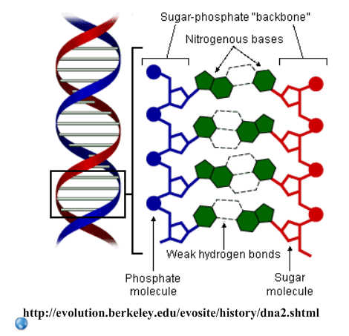
- Explain the relevance of the following in the double-helix structure of DNA:
- Complementary base pairing

- Hydrogen bonds

- Relative positioning of the sugar-phosphate backbone and the bases

- The discovery of the structure of DNA earned a Nobel Prize for Watson, Crick and Wilson.
Go to the Nobel Prize website: http://nobelprize.org/educational_games/medicine/dna_double_helix/readmore.html

Discussion - How is it a good example of the following:
- Internationalism in science?
- Cooperation in science?
- Competition in science?

Works Cited
1. Allott, Andrew. IB Study Guide: Biology for the IB Diploma. s.l. : Oxford University Press, 2007. 978-0-19-915143-1.
2. Mindorff, D and Allott, A. Biology Course Companion. Oxford : Oxford University Press, 2007. 978-099151240.
3. Clegg, CJ. Biology for the IB Diploma. London : Hodder Murray, 2007. 978-0340926529.
4. Campbell N., Reece J., Taylor M., Simon. E. Biology Concepts and Connections. San Fransisco : Pearson Benjamin Cummings, 2006. 0-8053-7160-5.
5. Taylor, Stephen. Science Video Resources. [Online] Wordpress, 2010. http://sciencevideos.wordpress.com.
6. Burrell, John. Click4Biology. [Online] 2010. http://click4biology.info/.
7. IBO. Biology Subject Guide. [Online] 2007. http://xmltwo.ibo.org/publications/migrated/production-app2.ibo.org/publication/7/part/2/chapter/1.html.

Self Assessment:
 | Essential Biology |  |  | Assessment
Criterion | Complete (2) | Partially complete (1) |  | Self | MrT
Presentation & Organisation | NA | Complete and neat. All command terms highlighted, tables and diagrams well presented.
Academic Honesty | NA | Sources cited using the CSE (ISO 690 numerical) method, with Works Cited section complete and correct.
Objective 1 understanding | All answers for the following command terms correct: | Most answers for the following command terms correct:
 | Define Draw Label List Measure State
Objective 2 understanding | All answers for the following command terms correct: |  | Most answers for the following command terms correct:
 | Annotate Apply Calculate Describe Distinguish Estimate Identify Outline
Objective3  understanding | All answers for the following command terms correct: |  | Most answers for the following command terms correct:
Analyse Comment Compare Construct Deduce Derive Design Determine Discuss
Evaluate Explain Predict Show Solve Sketch Suggest
Logic, notation, mathematical working | NA | Answers are presented in a logical and concise manner. SI units used most times, with correct unit symbols and definitions of terms. All mathematical working shown.
Further research | NA | Evidence is apparent of research and reading beyond the textbook and presentations to find correct answers to challenging questions. If any questions are unanswered, this criterion scores zero.
 | Total (max 10):

